**LAB REPORT NO 6**



**Spring 2020**

**CSE102L Computer Programming Lab**

Submitted by:  **Muhammad Ali**

Registration No: **19PWCSE1801**

Class Section: **A**

“On my honor, as student of University of Engineering and Technology, I have neither given nor received unauthorized assistance on this academic work.”

Submitted to:

**MAM. Sumayyea salahuddin**

Date:(January 12, 2021)

Department of Computer Systems Engineering

University of Engineering and Technology, Peshawar

**Activity 6.3.1:-**

**C++ code:-**

#include<iostream>

using namespace std;

class first{

protected:

int f;

public:

int f_input(){

cout<<"enter first number :";

cin>>f;

}

};

class second:public first{

protected:

int s;

public:

int s_input(){

first ::f_input();

cout<<"enter second number :";

cin>>s;

}

};

class third: public second{

protected:

int t;

public:

int t_input(){

second::s_input();

cout<<"enter third number :";

cin>>t;

}

int show(){

cout<<"\nfirst number is "<<f<<endl;

cout<<"second number is "<<s<<endl;

cout<<"third number is " <<t<<endl;

}

int max(){

if (t >s && t>f){

cout<<t<<" is the maximum number."<<endl;

}

else if (s>t && s>f){

cout<<s<<" is the maximum number.";

}

else {

cout<<f<<" is the maximum number.";

}

}

};

int main(){

third A;

A.t_input();

A.show();

A.max();

}

**Output:-**

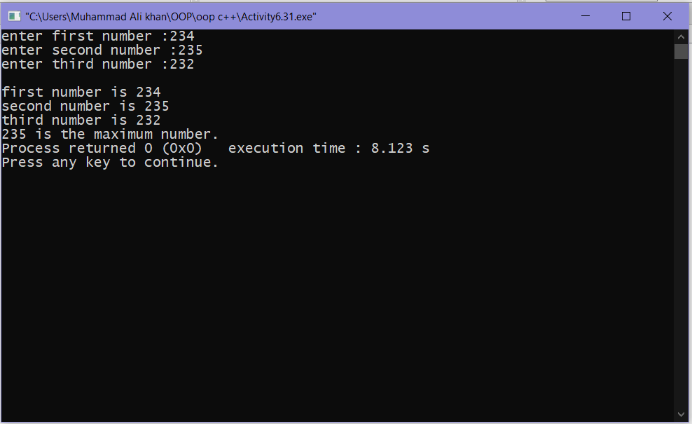

**Activity 6.3.2:-**

**C++ code:-**

#include<iostream>

using namespace std;

class base{

protected:

int ba;

public:

int ba_input(){

cout<<"enter base :";

cin>>ba;

}

int show_base(){

cout<<"base = "<<ba<<endl;

}

};

class exponent {

protected:

int exp;

public:

int exp_input(){

cout<<"enter exponent :";

cin>>exp;

}

int show_exp(){

cout<<"exponent = "<<exp<<endl;

}

};

class power: public exponent,public base{

protected:

int po;

public:

power(){

po=1;

}

int in1(){

base:ba_input();

exponent::exp_input();

}

int show1(){

base::show_base();

exponent::show_exp();

cout<<"power is :";

while (exp>0){

po=ba*ba;

--exp;

}

cout<<po;

}

};

int main(){

power A;

A.in1();

A.show1();

return 0;

}

**Output:-**

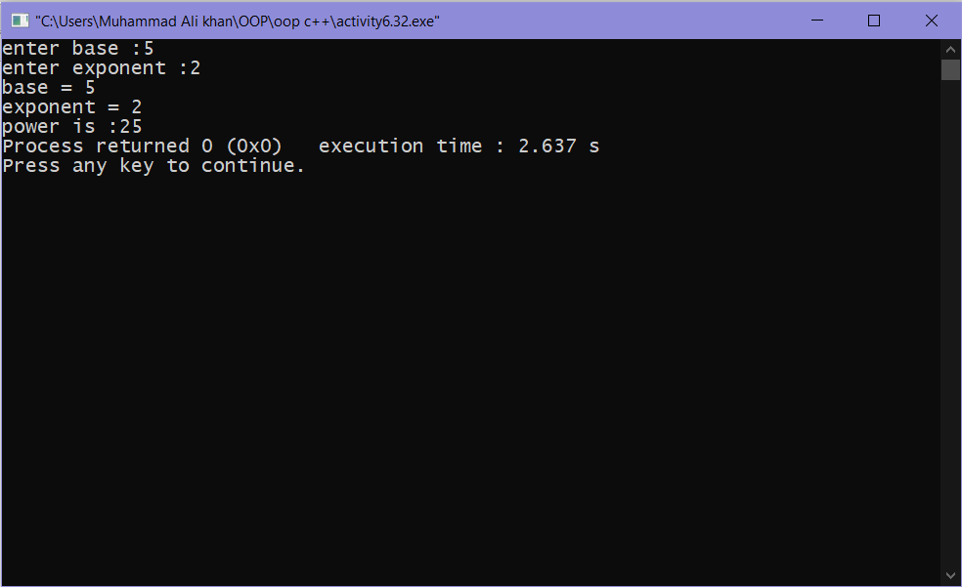

**Activity 6.3.3:-**

**C++ code:-**

**Cpp file:-**

#include<iostream>

#include"headerfile.h"

using namespace std;

int main(){

third A;

A.t_input();

A.show();

A.max();

cout<<"\n\n*********1st file executed********** \n";

power a;

a.in1();

a.show1();

cout<<"\n\n*********second file executed********** \n";

return 0;

}

**Header file:-**

#include<iostream>

using namespace std;

#pragma once

class first{

protected:

int f;

public:

int f_input(){

cout<<"enter first number :";

cin>>f;

}

};

class second:public first{

protected:

int s;

public:

int s_input(){

first ::f_input();

cout<<"enter second number :";

cin>>s;

}

};

class third: public second{

protected:

int t;

public:

int t_input(){

second::s_input();

cout<<"enter third number :";

cin>>t;

}

int show(){

cout<<"\nfirst number is "<<f<<endl;

cout<<"second number is "<<s<<endl;

cout<<"third number is " <<t<<endl;

}

int max(){

if (t >s && t>f){

cout<<t<<" is the maximum number."<<endl;

}

else if (s>t && s>f){

cout<<s<<" is the maximum number.";

}

else {

cout<<f<<" is the maximum number.";

}

}

};

class base{

protected:

int ba;

public:

int ba_input(){

cout<<"enter base :";

cin>>ba;

}

int show_base(){

cout<<"base = "<<ba<<endl;

}

};

class exponent {

protected:

int exp;

public:

int exp_input(){

cout<<"enter exponent :";

cin>>exp;

}

int show_exp(){

cout<<"exponent = "<<exp<<endl;

}

};

class power: public exponent,public base{

protected:

int po;

public:

power(){

po=1;

}

int in1(){

base:ba_input();

exponent::exp_input();

}

int show1(){

base::show_base();

exponent::show_exp();

cout<<"power is :";

while (exp>0){

po=ba*ba;

--exp;

}

cout<<po;

}

};

**Output:-**

